Architecture and Wireframe

Travel Package Purchase Prediction

Here I’ll show you how this web application works!!!

Travel Package Purchase Prediction:-

As the name suggests we’ll build a model that

predicts the probability of purchasing the travelling

package.

If talking about importance of it. It is quite a bit

interesting scenario – Suppose a travels and tours

company wants to know their sales, deals are

working or not. They do some analysis like

1. Age,

2. Monthly income,

3. Number of trips they want,

4. Are they male ,female or both,

5. Their job roles

And many many aspects………..

1. First you’ll see the beautiful header of my application.

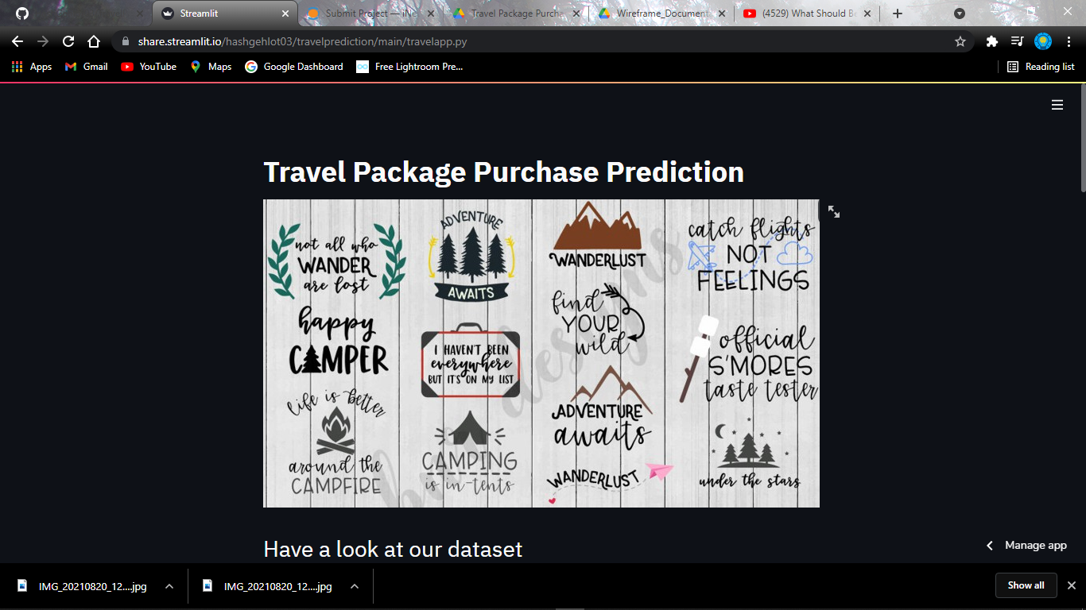

1. Now just get familiar with the dataset by looking it and its list of features.

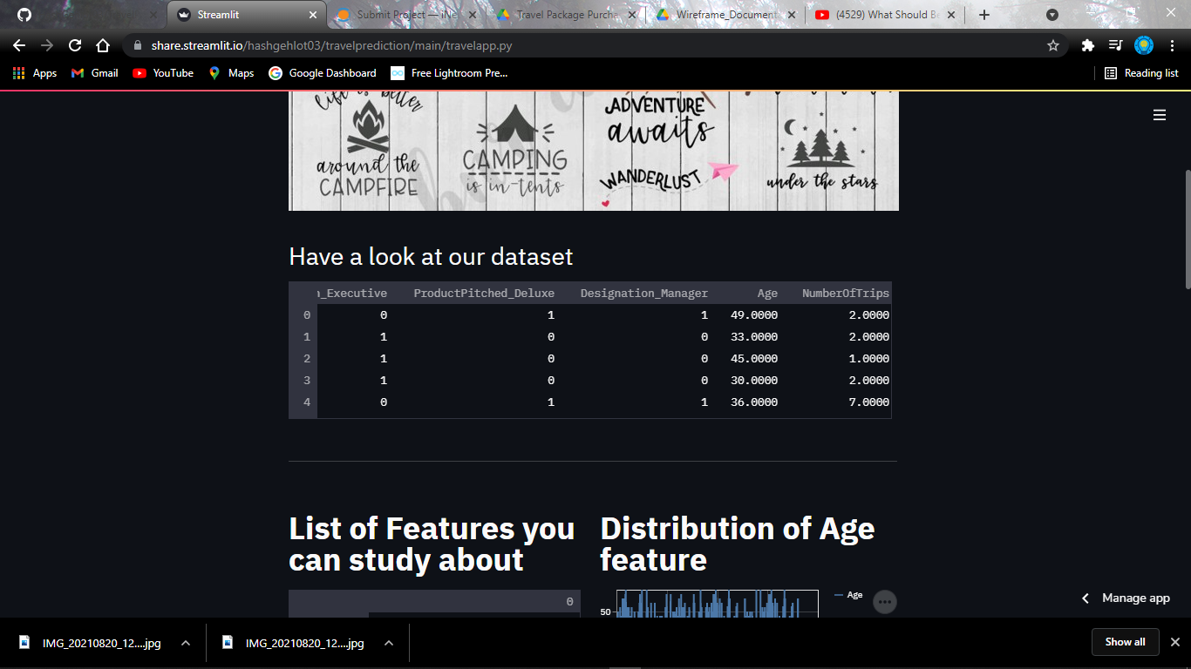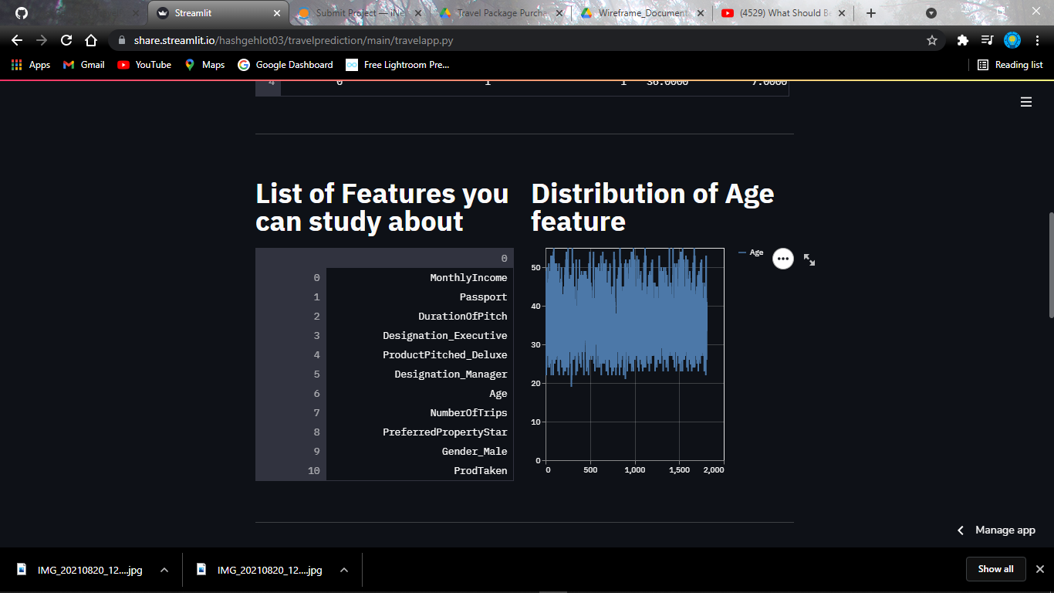

1. Now the most interactive part that is the prediction that traveler will purchase the product or not.

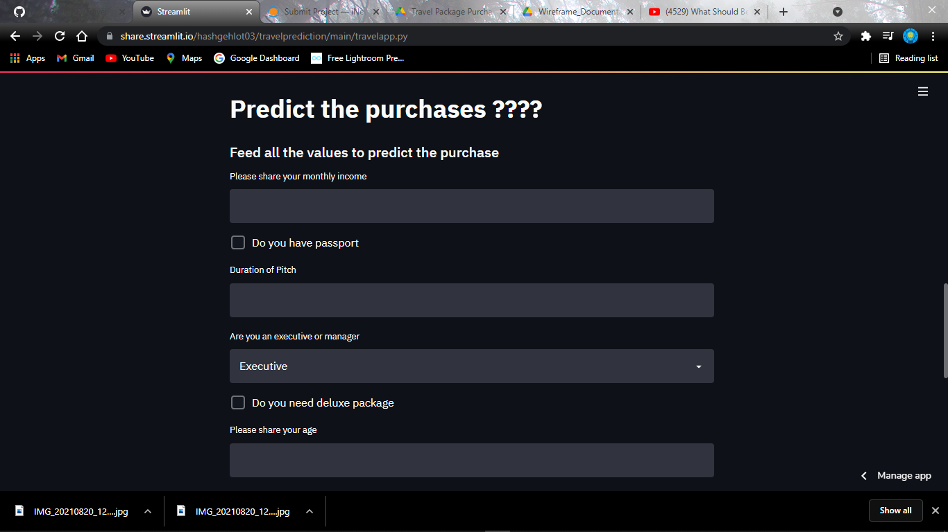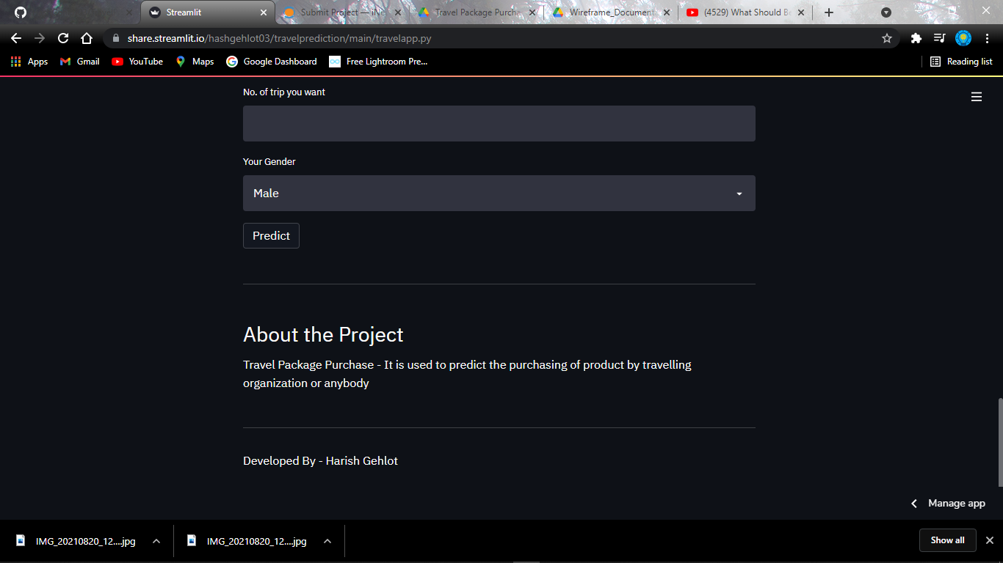

Simply feed the values like monthly income, passport and many more.

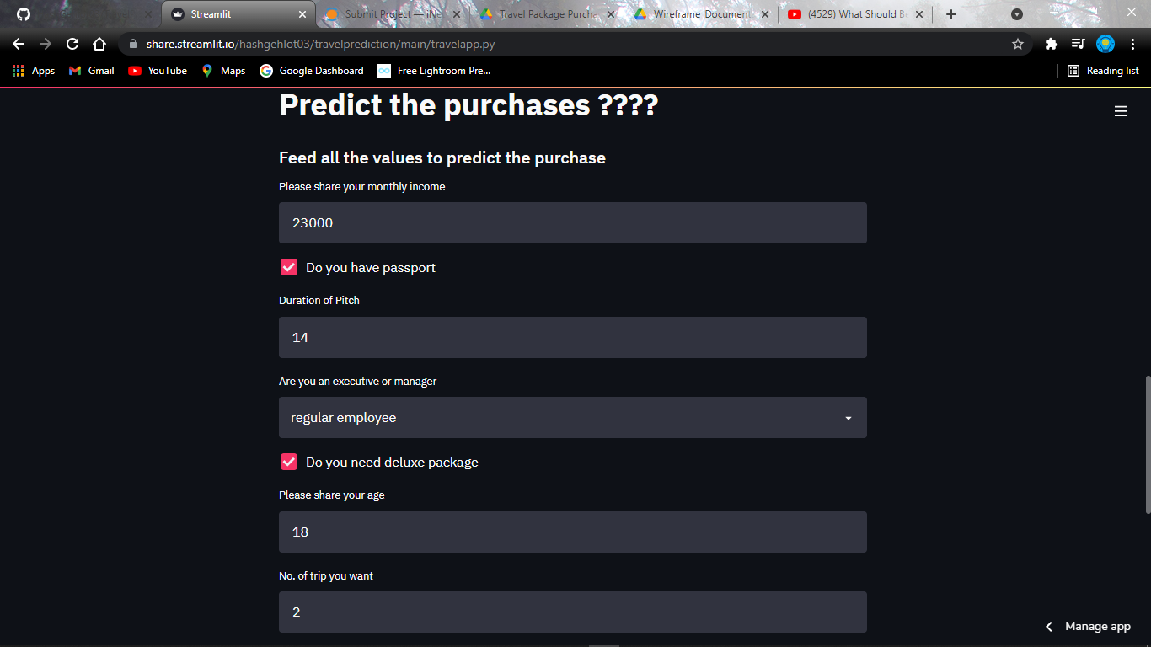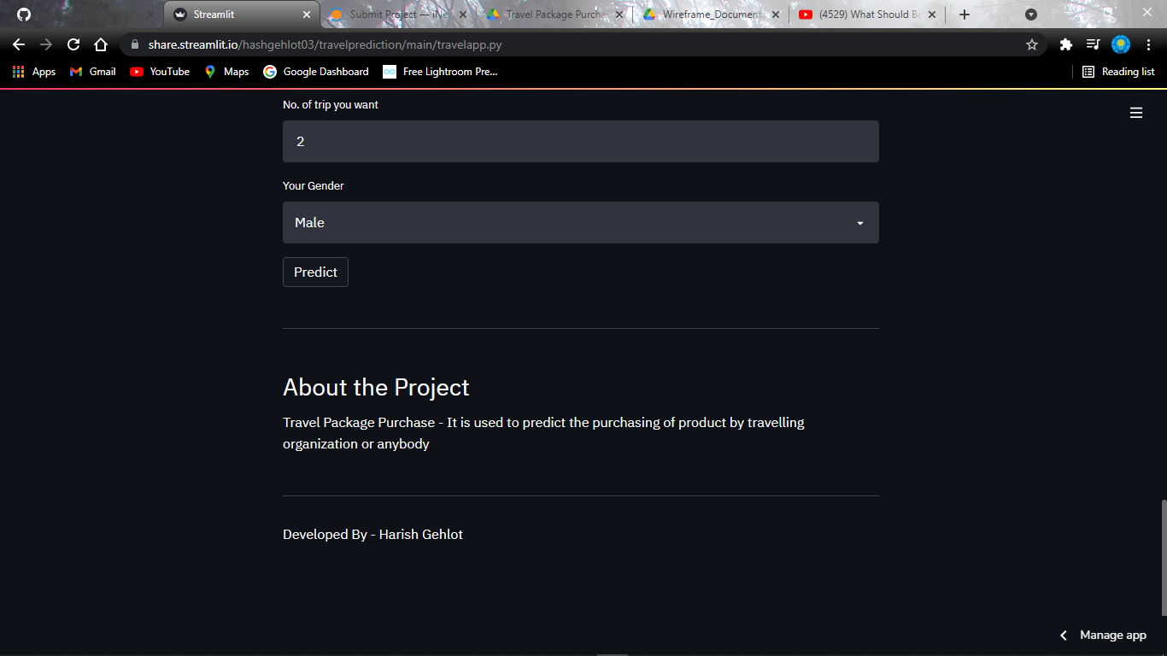

Just click on predict and you got your prediction result.

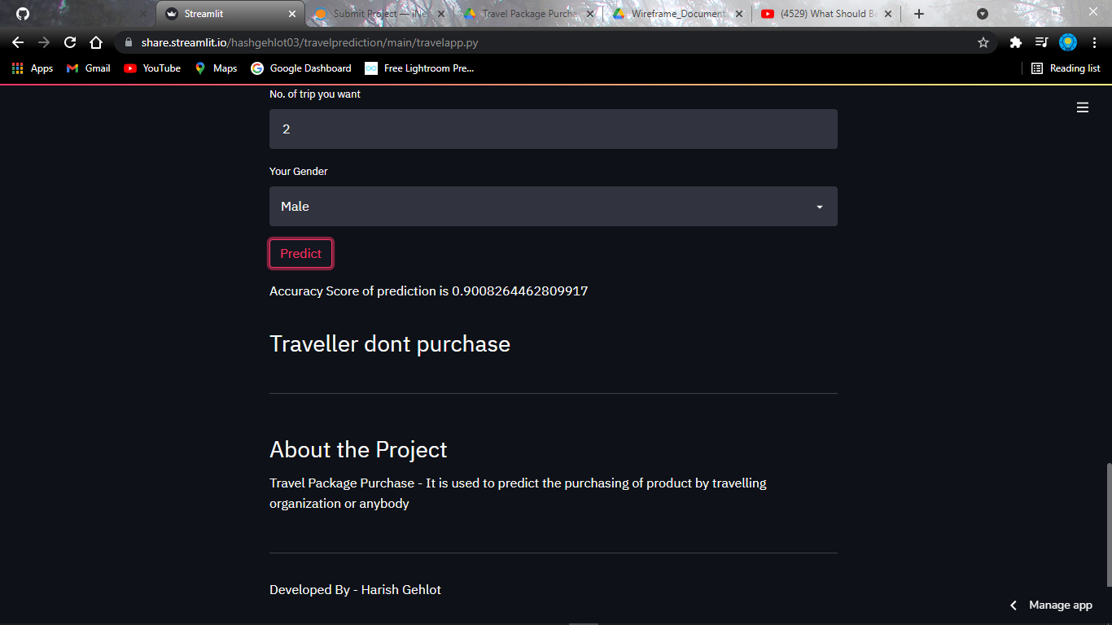

Thank you for visiting my web application and having a prediction.

